SIMATS ENGINEERING CHENNAI
CO3-AT3 COURSE CODE: ITA0612
COURSE NAME: MACHINE LEARNING COURSE FACULTY: Dr. SHRI VINDHYA.A

NAME: Y.S.Anil Prasad
REG NO: 192312034

Question 1 Design and conduct an experiment to implement a Naïve Bayes classifier on a real-world dataset. Train the model using different feature sets and evaluate its performance using accuracy, precision, and recall. Analyze how assumptions of feature independence affect the results. Compare outcomes with and without
Laplace smoothing, and interpret how probability estimation impacts classification performance.

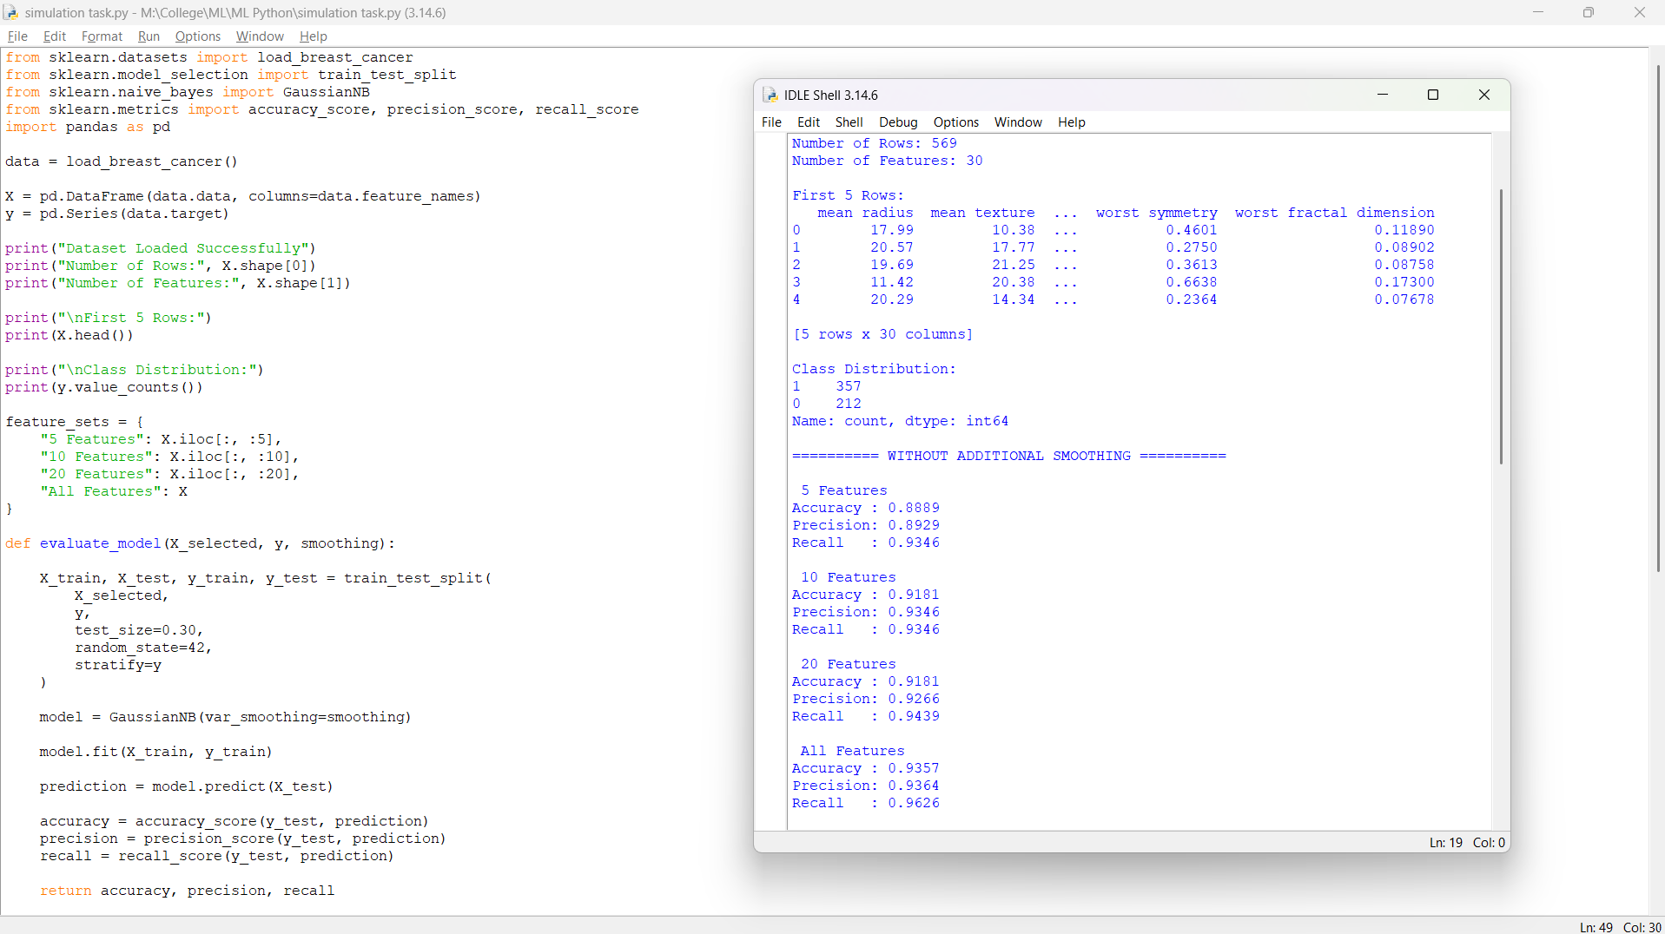

Question 2 Perform an experiment to estimate parameters of a probability distribution using Maximum Likelihood Estimation (MLE) and compare it with a Bayesian estimation approach. Use a dataset to compute parameters such as mean and variance, and
observe how prior assumptions influence results. Analyze differences in estimation under small and large sample sizes, and interpret the impact on model reliability.

